Profile of top 10 prestigious journals that cited my papers

Journal of Nutrition

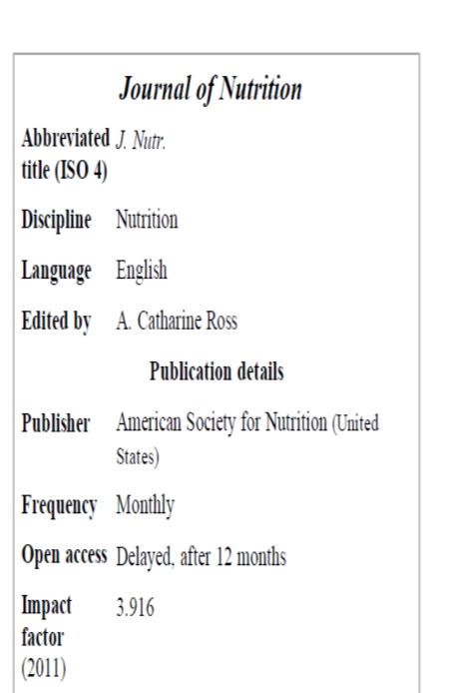

Frontiers in Human Neuroscience

International Journal of Psychophysiology
International Journal of Psychophysiology
Description | Peer-reviewed journal
Special field | Medicine and Physiology
Language | English
Publishing house | Elsevier ( The Netherlands )
First | 1983
Published | 12 / year
Weblink | Website of the journal
ISSN | 0167-8760

